**Monthly Calendar**

HTML concepts are almost used in every field like web designing, promotional websites, etc., in and around us. Especially, the table concept is being used in many real-time scenarios. Whenever the content delivery has to take place in forms of rows and columns, table format proves to be the best for implementation as it provides proper alignment of data. One of the best real-time applications of table concept is the Monthly Calendar.  
Hence, create a web page which displays the monthly calendar using the table concepts mentioning all the special days with unique styles.                                           
  
**Constraints :**  
table tag must be present 3 times in the html page.  
For every sunday's, apply the style property color - #FF0000 for that particular td.  
Use thead and tbody tags for designing table.  
  
**Note :**  
The web page should be present as shown in the screenshot.  
  
**Sample Screenshot 1 :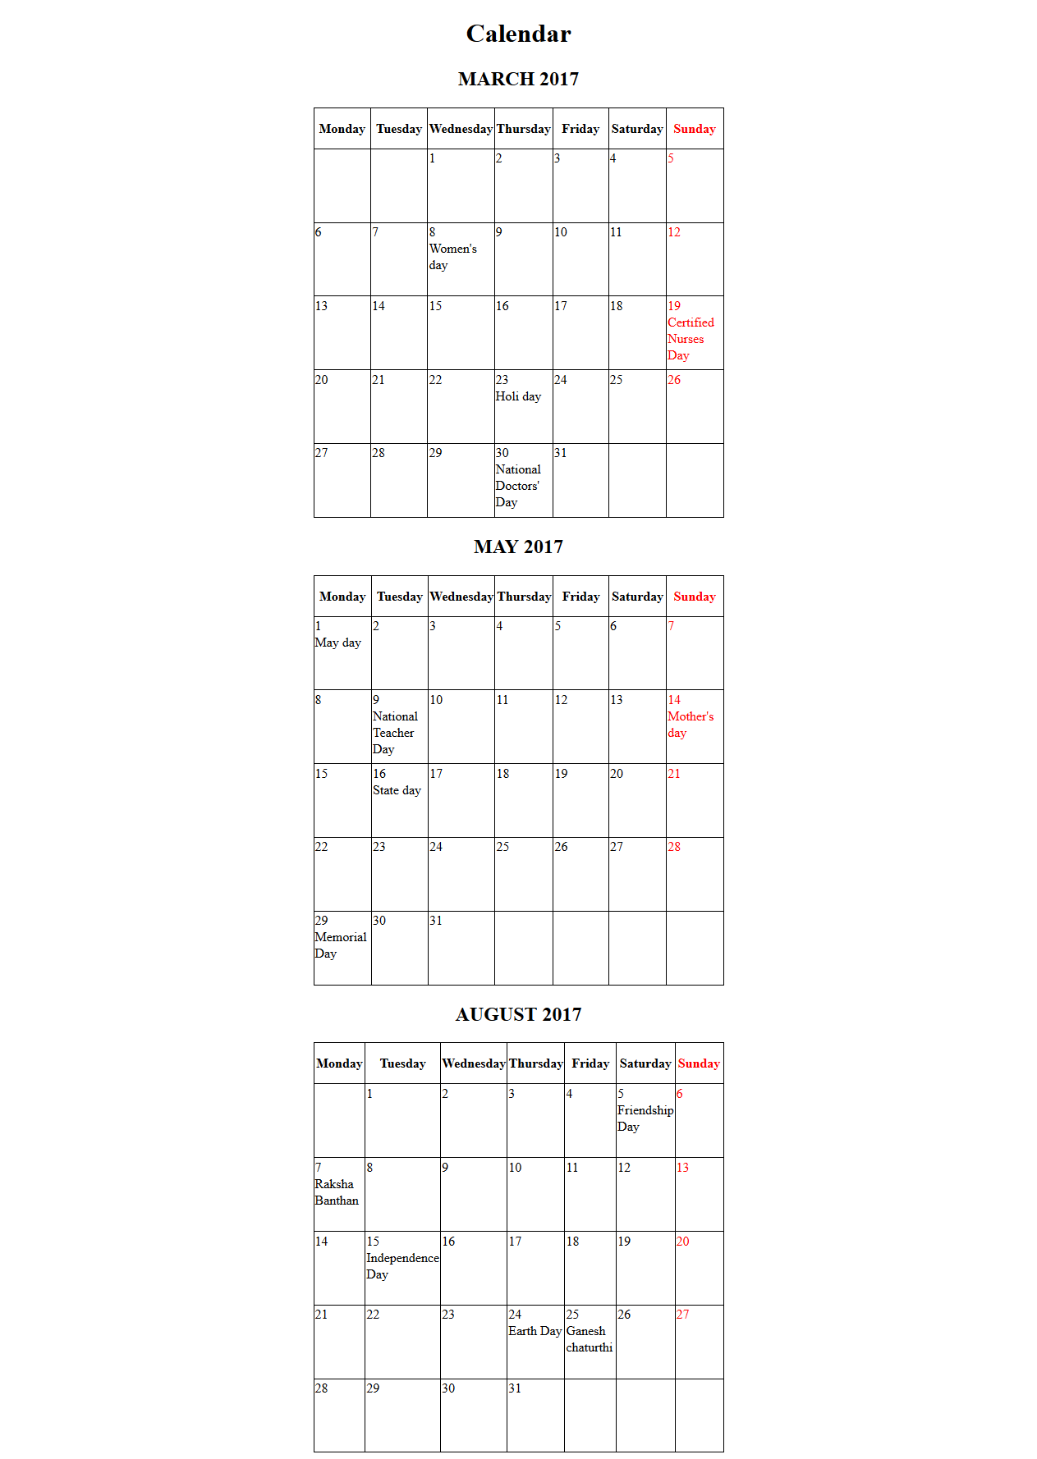 Sample Screenshot 2 :**

